**Mean Variance Portfolio Theory**

**Risk & Return of a Risky Asset**

# Expected Return

* The **Return** on an asset is the **percentage increase in the price** of the security compared to how much was initially invested in it
* We cannot know for sure what will happen in the future. **Each possible future** will result in a **different return on an asset** (Probability Distribution)
* Thus, we consider the **Expected Return** instead, which is the **probability weighted average** of the possible returns







# Risk of Returns

* The actual return will most likely be **different from its Expectation.** This uncertainty in the returns is known as **Risk**
* We can measure this Risk through **Variance** & **Standard Deviation:**
  + Variance is the **expectation of the squared deviation from the mean**
  + Standard Deviation is the **square root of Variance**
* Standard deviation is also known as the **Volatility** of returns and is the preferred measure since it has the **same units as the Return**
* Although the expectation is a key component of the formula, assets with the **same expectations can have different Volatilities**





## Expectation and Variance

|  |  |
| --- | --- |
| **Expectation** | **Variance** |
|  |  |
|  |  |
|  |  |







|  |  |
| --- | --- |
| **Expectation** | **Variance** |
|  |  |

# Using Historical Data

* The above assumes that **we know ALL possible information** about the possible outcomes - but in reality we only have a **Sample** of the information from historical data
* Thus, we use **Sample Statistics** instead of the Population measures
* Sample Statistics are meant to **estimate Population Measures** - If in large samples, the Statistic approaches the Population Measure, then we say that the **Statistic is unbiased**
* Note that the calculator can compute both **Sample and Population measures**
  + **Frequency set to 1** → Sample Statistics
  + **Frequency set to a Column** → Population Measures
  + Remember to refer to the **correct symbol** - both will be calculated regardless

|  |  |
| --- | --- |
| **Sample Statistics** | **Population Measure** |
|  |  |
|  |  |



|  |  |
| --- | --- |
| **Sample Mean** | **Sample Variance** |
|  |  |
|  |  |

## Two types of Means

* **Arithmetic** Mean is usually used as an **estimate** for the Expected Return
* **Geometric** Mean is usually used as an **historical measure** of the return over a period (Assuming dividend reinvestment)
* If the number of observations are large, then the Arithmetic mean is an **unbiased estimator** of Expectation

## Standard Errors

* Since **each sample is different**, each sample statistic will also be different, even if in the limit it is an unbiased estimator
* We can measure the extent of this error using **Standard Errors & Confidence Intervals**
  + Standard Error is the **standard deviation of the sample mean** from the population mean
  + Confidence Intervals represent the **probability** that the population mean will fall within the calculated bound of the interval

Assuming returns are Independent of one another,

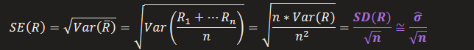

* A key issue is that the population standard deviation is often **not known**
* Thus, that component is approximated with the **Sample Standard Deviation**

From empirical evidence, we assume that the returns are approximately **normally distributed**,

* 
* 
  + If we use the **sample standard deviation** to calculate the SE, we should **rightfully use the t-distribution** instead to calculate the confidence interval
  + However, if we additionally **assume that the sample sizes are sufficiently large,** then there is a **negligible difference** between whichever is used

# Risk and Return among Asset Classes

* Naturally, Stocks have higher risk and return compared to Bonds
* Based on the past few decades, **SMALL Cap stocks have performed the best**, followed Large Cap and then International stocks
* Note that this takes a US perspective - Small and Large Cap stocks are in the US

**Risk & Return of a Risky Portfolio**

# Portfolio Return

* Similarly, we consider the **Expected Return on a Portfolio (Collection of Risky Assets)**
* The Return is the **market-valued weighted average** of the returns of each asset







# Covariance & Correlation

* When considering more than one asset, we need to consider the **Covariance**
* Covariance measures the **linear relationship** between two or more variables:
  + **Positive Covariance** → Variables move in the **same direction**
  + **Negative Covariance** → Variables move in **opposite directions**





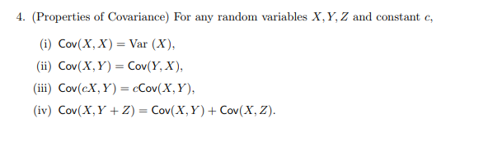

# Correlation

* However, Covariance has two main issues – **Limitless magnitude** & **squared units**
* Thus, we consider the **Correlation** instead which a **unitless** measure of the **Strength and Direction** of the Linear Relationship
* Note that correlation measures tendency - not guaranteed





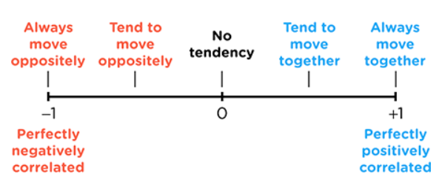

# Portfolio Risk

* Based on the properties of Covariance, we can express the Variance of the portfolio as the **Covariance with itself**
* By substituting in the formula for the Portfolio Return, we can further simplify the variance to a **summation of each pair of covariances multiplied by their weights**

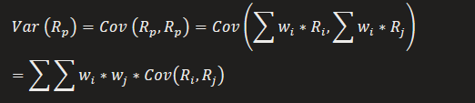

## Covariance Matrix

* We can expand the Covariance term into a **Matrix of Covariances**
* There are two interesting properties to note:
  + Terms on the diagonal are covariances with itself (Variance)
  + Terms on **either side of the diagonal are identical** to their counterparts on the other side
* To sum it up,
  + 
  + 
  + 

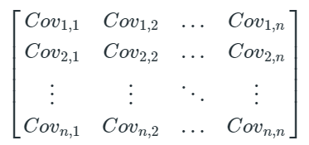

## Matrix Multiplication

* Thus, we can reduce the double summation into a Matrix Multiplication
* The key is to ensure that only get one final term as our result

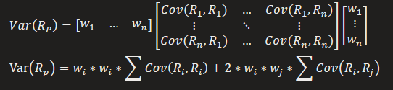



## Total Number of UNIQUE Inputs

* Combining everything from the past two sessions, we obtain the total number of unique inputs needed
  + 
  + 
  + 
* 

# Portfolio Diversification

* **Systematic Risk** → Related to the **entire market** & **cannot be diversified** away
* **Non-Systematic Risk** → Related to a **specific** firm/industry & **can be diversified** away
* Diversification works through the **law of large numbers.** By building a **sufficiently large** portfolio of **different assets that are not highly correlated**, the non-systematic fluctuations will average out, leaving only non-systematic risk
  + The **rate** at which non-systematic risk is diversified away **decreases** as the **number of assets increases** (Already diversified)

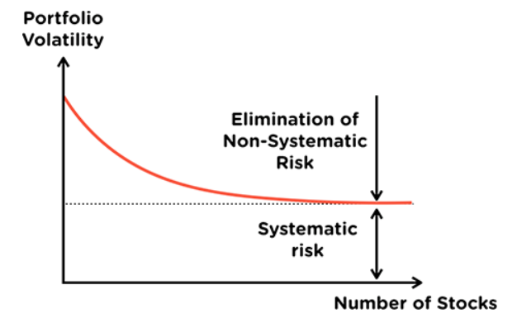

 This means that stocks are to **some extent positively correlated with one another** since they are affected by the same systematic economic factors

Alternatively, we can find the Portfolio Variance through Covariance,











* 





* Thus, portfolio volatility will always be less than the sum of individual volatility
* This is because non-systematic risk has been diversified away

Thus, each asset contributes a risk proportionate to its weight and correlation in the portfolio,







* Volatility is the sum of each asset's volatility scaled by its **weight & correlation with Portfolio**
* Thus each assets contribution to the volatility is **simply that component**

# Special Case: Equally Weighted Portfolio

* 





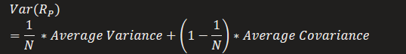

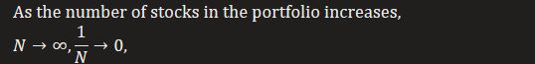



**Markowitz Optimization**

# Risk Tolerance

* Individual’s **preference for certain payoffs** over uncertain payoffs
* Consider a **fair game:**
  + Game with **equal probability** for a positive (+200) & negative outcome (-100)
  + **Priced at the expectation** of the game (100)
* We can **determine Risk Tolerance** by determining their reactions to a fair game:
  + **Risk Averse** → Avoids fair games
  + **Risk Neutral** → Neutral to fair games
  + **Risk Loving** → Seeks out fair games
* We can explain this by considering the Utility Curves of these individuals:
  + **Risk Averse** → Convex Utility (RHS)
  + **Risk Neutral** → Linear Utility
  + **Risk Loving →** Concave Utility (LHS)
* The Orange Line below represents the **Fair Game** while the Blue Curves represent the Utility Functions:
  + For a **Risk Averse** person, they gain **higher utility from a guaranteed payoff**
  + For a **Risk Loving** person, they gain **higher utility from the expected payoff**
  + **Risk Neutral** people have a utility curve that is **identical to the payoff line** thus they gain the **same utility either way**

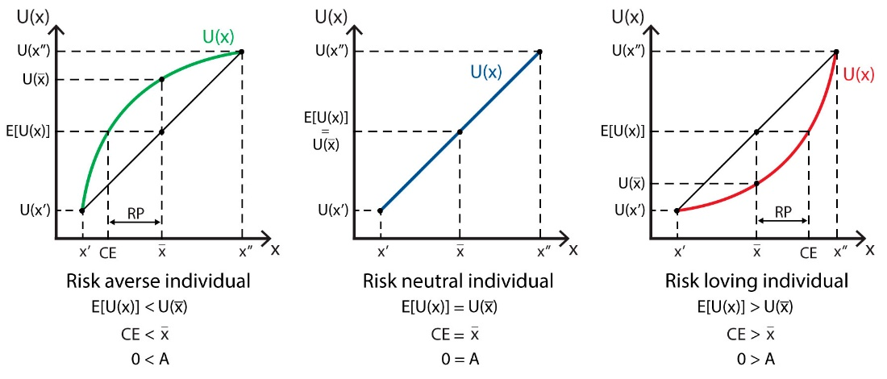

## Risk Aversion

* We assume that **all individuals are Risk Averse to some extent**
* Risk Averse individuals only go for **Risk Free investments** or a **Risky Investment with a sufficiently positive risk premium**
  + Risk Premium is the **reward** for taking risk, **excess over** the risk-free return
* To **quantify how high** is sufficient, we consider their **Utility function**
  + From a different perspective, it can be viewed as though a Risk Averse investor places a **Risk Penalty** on the expected returns
  + All investors are **Risk Averse to some extent** – measured via the Risk Aversion index (A)
* We can draw a few conclusions about Risk Averse investors:
  + Given the **same level of return**, they prefer **less risky investments**
  + Given the **same level of risk**, they prefer **higher returns**
  + By prefer, we mean to **gain more utility from it –** thus utility increases towards the **northwest** direction
* All portfolios with the same utility can be connected to form an **Indifference Curve, as seen above**



# Efficient Frontier

* Consider a portfolio of **Risky Assets –** Consider **every possible allocation of capital** between them and plot their Returns & Risks onto a graph
* The graph will always be **C-shaped** & have an inflexion point known as the **Global Minimum Variance Portfolio**
  + This inflexion point can be calculated by solving for the weights that **minimize the variance** of the portfolio (Excel Solver)
  + The **more diversified assets** there are, the **lower the correlation of the portfolio,** thus the **variance can be further lowered**, shifting it **more left**
* All portfolios above the inflexion **point** will always have the **same risk** as a portfolio directly below it **but with higher return.** A risk averse investor will thus **always prefer a portfolio above the inflexion** to one below the inflexion
* This set of preferred portfolios **above the inflexion** is known as the **Efficient Frontier**
  + It represents the set of ALL possible portfolios that a rational risk averse investor will **consider investing in**

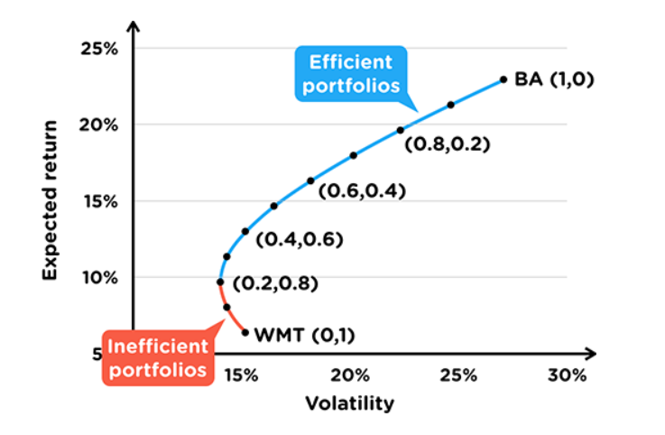

## Identifying End Points

* For a two stock portfolio, substitute in the end points (100,0) for each stock to identify which stock is on the Efficient or Inefficient end

## Perfectly Hedged Portfolio

* 
* By setting the **SD of the portfolio to 0**, we can solve for the **weights of the perfectly hedged portfolio**
* The expected return using these rates **have no risk**, thus is the **Risk-Free Rate**
* We observe a **two-asset** example below:















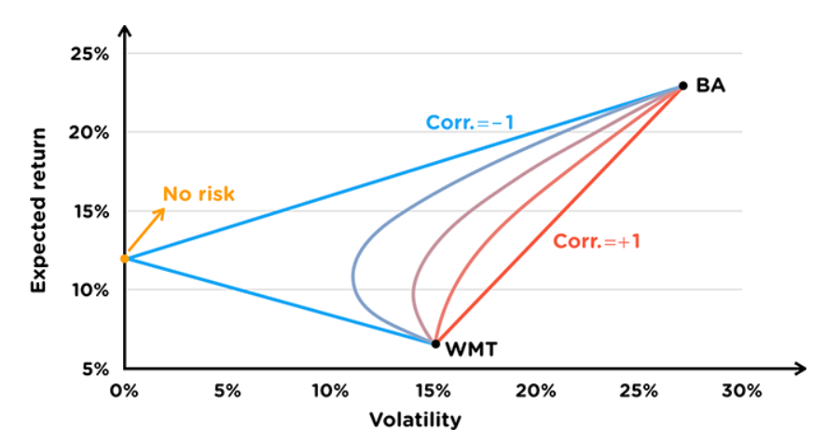

|  |  |
| --- | --- |
| **Highest Possible Variance** | **Lowest Possible Variance** |
| Perfectly positively correlated | Perfectly negative correlated |
|  |  |
| Linear Graph | Triangle Graph |

Note that Variance is **only reduced if there is negative correlation** between assets

## Short Positions

* **Negative weight** in a stock – selling one stock for leverage (Others become >1)
* This **extends the graph**, **expanding the set of efficient portfolios**

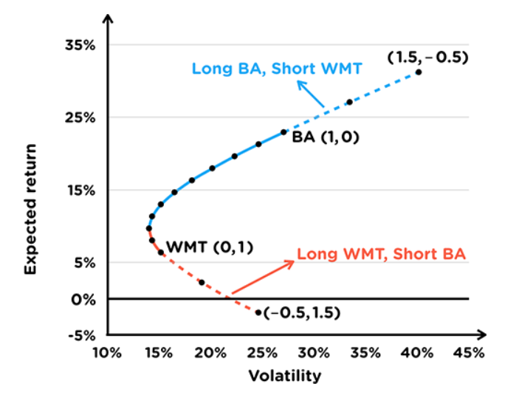

# Risky Portfolio + Risk Free Asset

* A Risk-Free asset has a **fixed return** and thus has **0 volatility**. Given this, it also has **no correlation** (Independent) with the Risky Portfolio
* We then **split our capital** into two, based on what proportion we want to invest inside the **Risk-Free** asset and our **Risky Portfolio**
* The **Expected return** for our combined portfolio is simply the **weighted average of the returns** while the **volatility** is a **fraction of that of the risky portfolio**





Since the risk-free asset is independent and has no volatility,





## Capital Allocation Line

* By rearranging and then substituting the Volatility into the Expected Return, we obtain a linear expression **relating the Return of the portfolio to its Risk**
* This is known as the **Capital Allocation Line** (CAL) which shows the **various combinations** of Risk & Return an investor can obtain with a Risk Free Asset & Risky portfolio
* We can visualize the equation on our graph in the form of a **line**:
  + The gradient of the line is known as the **Sharpe Ratio** which represents the **additional return per additional unit of risk**
  + The line extends **beyond the volatility** of our Risky Portfolio, which represents situations where **more than 100%** is invested into it
  + This is done through **selling the Risk-Free asset** (Negative weight) and using the proceeds to **buy the Risky Portfolio** on margin/leverage

Substituting the Volatility into the Expected Return,











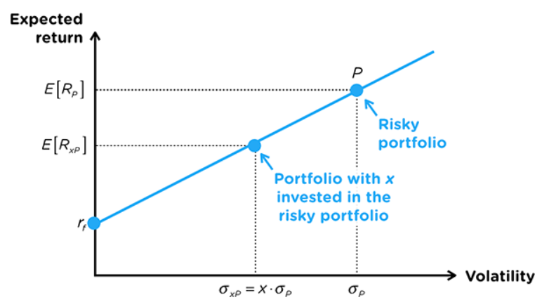

The Sharpe Ratio for **ANY combination** of the Tangent Portfolio and Risk Free Assets is the **SAME**

This combination of the Tangent Portfolio and Risk Free Assets will **outperform any other combination (Any combination will be efficient)**

# Optimal Risky Portfolio

* The question is – **which risky portfolio** should the CAL use?
* We know the CAL should reference a portfolio on the **Efficient Frontier –** but which?
* A risk averse investor always ways to **maximize their return per unit risk** thus we should choose the risky portfolio that **maximizes the Sharpe Ratio** (Steepest Gradient)
* This is obtained when the CAL is **tangent** to the efficient frontier – **Tangent Portfolio**

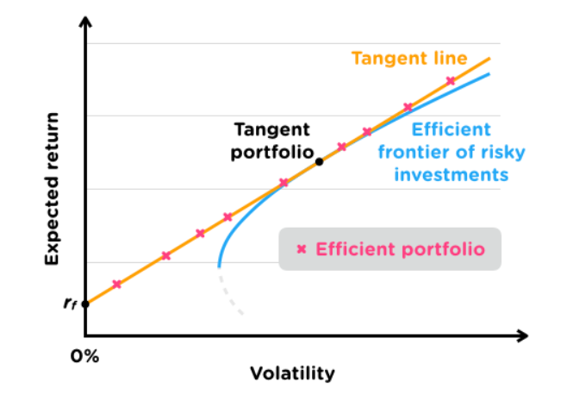

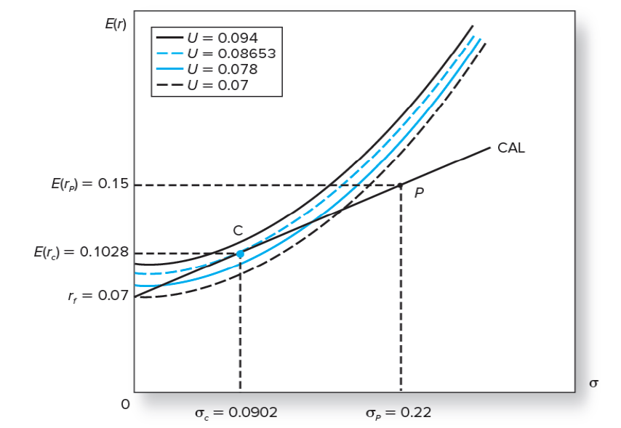

* Investors will then choose which portfolio along the tangent CAL that they want
* This choice is based on the **level of Risk Aversion**:
  + Graphically, this is the point where the **highest indifference curve** is **tangent to the CAL**
  + Mathematically, we can quantify this by using the **Utility Function** we defined earlier by **maximizing it with respect to the weight of the portfolio**
* This combination of a Risk-Free Asset and Risky Portfolio is the **Optimal Complete Portfolio**

We substitute the Return and Volatility of our CAL into the Utility Function,











#### 